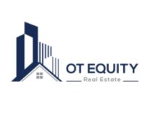Business Plan

Prepared on:
[1/11/2022]

Prepared by:
[OT Equity LLC]

OVERVIEW
Our overall goal is to raise $10M from 100 accredited investors or less to acquire multifamily real estate assets starting in 2022 and subsequently split the profits with investors.

TABLE OF CONTENTS
Overview 1
Executive summary 4
Objectives 4
Objective 1 4
Objective 2 4
Objective 3 4
Company 5
Company Ownership 5
Company History 5
Company location 5
What sets us apart? 6
External environmental analysis 7
Swot analysis of acquisitions 7
Porter’s five force analysis of acquisitions 8
Drivers of change 9
Key success factors 9
PRE-TRANSACTION success factors 9
post – transaction success factors 10
Acquisition plan 10
Financing plan 11

EXECUTIVE SUMMARY

OT Equity, LLC is a Texas Limited Liability company with offices in Dallas, TX, is arranging for the acquisitions of multiple multifamily apartments to add to our first multifamily real estate portfolio with the help of a limited number of accredited investors.
We are seeking a total investment of $10M with a minimum of $100,000 per investor. Investors receive 75% equity with projected average annual returns of 13%-26% or more. Cash flow distributions are made at the end of each calendar year.
Investors should be prepared to leave their money in for a minimum of 3-5 years, even though there is a possibility to re-finance and repay the investor’s principal before then. Investors have the option of getting cashed out of their investment between year 4 and 5 at 90% of fair market value of their shares. If we re-finance or sell any properties, investors first receive their principal back, then receive 75% of any profits.
OBJECTIVES

OBJECTIVE 1

Synergy: acquisitions companies can often reduce its fixed costs by removing duplicate departments or operations, lowering the costs of the company relative to the same revenue
stream, thus increasing profit margins.
OBJECTIVE 2

Increased revenue or market share: This assumes that the company that acquire will be
absorbing a major competitor and thus increase its market power.

OBJECITVE 3
Economy of scale: By spreading the operations on a larger scale, the company will reduce its
fixed costs.

COMPANY
OT Equity, LLC is an opportunistic real estate investment firm located in Texas with a focus on value-add and distressed multifamily investments. We enhance project value through precise capital investment and repositioning of management operations to provide superior risk-adjusted returns. We employ a professional third-party management company with a high level of expertise.
COMPANY OWNERSHIP
OT Equity, LLC is a privately held business structured as a Limited Liability Company
COMPANY HISTORY
Founded in 2020, OT Equity represents clients in the sale, merger, purchase, and valuation of closely held investment properties across the United states.
COMPANY LOCATION
The company has two addresses:

Business Address
17250 DALLAS PKWY
DALLAS TX 75248
832-669-3270

Mailing Address
10228 E NORTHWEST HWY UNIT 231
DALLAS TX 75238

WHAT SETS US APART?

MARKET ANALYSIS

Comparison Factor | Most PE Firms | OT Equity
Management Fee | 2% annual of committed capital | We charge a 3.75% flat acquisition fee. There are no other fees.
Process Dynamics | Bloated auction with 3rd party “experts,” lawyers, investment bankers, parent entities | Friendly founder-to-founder transaction
Management of Portfolio Companies | Minimal involvement, quarterly board meetings | Marketing and development included in carry
Transaction Speed | 5+ months of diligence, negotiations, auction process, etc. | < 30 days from deal sourcing to close
Investment Choices | Relinquish all control following fund commitment; opaque decision process with no influence per deal | Choose only the investments you like. Full control of how funds are disbursed
Capital Deployment Period | 5-10 years per fund. Capital is unused in low interest-bearing accounts prior to deployment | Capital is raised and deployed on demand
Partner Backgrounds | Purely financial (investment banking) | Focused on growing companies
Investment Strategy | Investments based on wide range of investment themes | Investments made in products / end markets / tech stack where Partners are specialized
Management Team | Independent management team for each portfolio company | One lean and centralized cross-functional team

EXTERNAL ENVIRONMENTAL ANALYSIS
The external environment is the context and the conditions of the industry where the business is operating. A thorough analysis of the general context as well as the external environment is of crucial importance for setting the business strategy. There are several methods for analyzing the external environment such as SWOT analysis, Porter’s five forces model, identification of the driving forces of the industry as well as the key success factors.

SWOT ANALYSIS OF AQUISITIONS
 | Strengths:  Strong capital position Low debt  Defensible intellectual property  Best salespeople | Weaknesses:  Better branding  Products not differentiated enough Possible product or service failure
 | Opportunities:  Strong financial position to make acquisition Acquire market share through branding  Hire more talent | Threats:  Competitors could leverage brand strength  Lack of differentiation could lead to potential price war  Possible loose of talent

PORTER’S FIVE FORCE ANALYSIS OF AQUISTITIONS

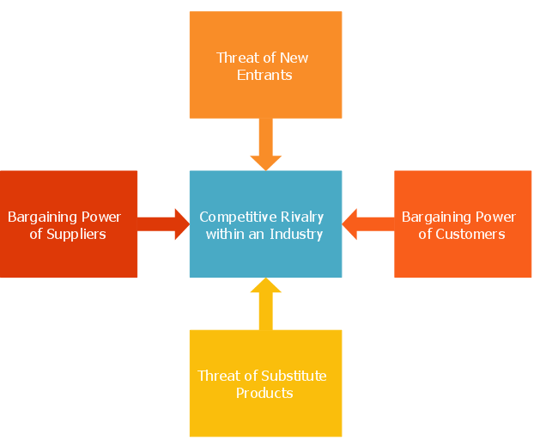

Porter’s five forces factors that might affect acquisitions

Threat of new entrants (Economies of scale; Product differentiation; Brand identity/loyalty; Access to distribution channels; Capital requirements; Access to latest technology; Access to necessary inputs; Absolute cost advantages; Experience and learning effects; Government policies; Switching costs; Expected retaliation from existing players)
Bargaining power of suppliers (Number of suppliers; Size of suppliers; Supplier concentration; Availability of substitutes for the supplier’s products; Uniqueness of supplier’s products or services (differentiation); Switching cost for supplier’s products; Supplier’s threat of forward integration; Industry threat of backward integration; Supplier’s contribution to quality or service of the industry products; Importance of volume to supplier; Total industry cost contributed by suppliers; Importance of the industry to supplier’s profit).
Bargaining power of buyers( Buyer volume (number of customers); Size of each buyer’s order; Buyer concentration; Buyer’s ability to substitute; Buyer’s switching costs; Buyer’s information availability; Buyer’s threat of backward integration; Industry threat of forward integration; Price sensitivity)
Threat of substitute products or service (Threat of substitute products or services; Number of substitute products available; Buyer’s propensity to substitute; Relative price performance of substitutes; Perceived level of product differentiation; Switching costs; Substitute producer’s profitability & aggressiveness).
Rivalry among existing competitors (Number of competitors; Diversity of competitors; Industry concentration and balance; Industry growth; Industry life cycle; Quality differences; Product differentiation; Brand identity/loyalty; Switching costs; Intermittent overcapacity; Informational complexity; Barriers to exit).

DRIVERS OF CHANGE
The drivers of change become more vital in the case of merger and acquisitions as it does not affect one or few employees rather it has the widespread reach and effect. Among the numerous drivers of change for the future, I have selected the following ones which are considered to have the greatest impact in the acquisitions:
- Geopolitical changes

- Environment changes
- New business models
- Technology
- Change in salaries and compensation packages

- Change in career paths

- Changes in job – new roles and assignment

- Change in benefits

KEY SUCCESS FACTORS
Bringing a newly merged entity safely into harbor requires a favorable climate composed of critical success factors. The key factors in the case of acquisitions can be divided in two parts, pre - transaction success factors and post – transaction success factors.

PRE-TRANSACTION SUCCESS FACTORS
Choose the right partner

Trust between the two companies i.e. the acquired and the holding company
Due diligence and good valuation1
Previous experience on M&A
Communication before the execution of the acquisition

POST – TRANSACTION SUCCESS FACTORS
Qualitative plan

Execution of the plan and implementation policy Trust between parties (also needed in this phase) Communication during the implementation Strategic, organizational and cultural fit Evaluation of synergies2
ACQUISITION PLAN
OT Equity will acquire multifamily apartment complexes with value-add opportunities that will force appreciation and provide strong returns for our investors. We look for structurally sound, underperforming properties in strong, growing markets. Once acquired, we develop and implement a strategy to increase value, cash flow, and net operating income. Our portfolio would include both short-term rentals and long-term rentals.

TEAM
The main team will be the BAIL team, but post-acquisition we would be working with property managers, accountants, and other necessary company staff.
Board of Advisors (Real Estate Consultant)  Michael Blank is an entrepreneur through and through and passionate about helping people become financially free with real estate investing. He’s the author of the Amazon bestseller “Financial Freedom with Real Estate Investing” and host of the popular Financial Freedom with Real Estate Podcast. He's helped investors purchase over 9,500 units valued at $445M through his training programs. As CEO of Nighthawk Equity, he controls over $200M in multifamily real estate. | Acquisition Entrepreneur  Oluwaseun Adeniji, as the CEO of OT Equity, will oversee raising capital, analyzing deals from brokers, applying for acquisition loans.
Investors  Investors, provide capital in exchange for equity. | Lawyers  Roman Law Firm, are experts at Real Estate Law.
Commitment to Full Transparency: Investors receive monthly newsletters with portfolio updates, P&Ls, deal pipeline.

DEAL STRUCTURE
 | Business Model | LBO model: 20% equity infusion from investors and 80% debt from acquisition loan.
 | Acquisition vehicle | Acquisitions would be carried out under a newly formed Series LLC
 | Post-closing organization | Holding company: to preserve the acquired company culture and to implement earn- outs.
 | Tax structure | To avoid a high taxation resulting from a holding company, they could: use more stock than cash; start the holding in for example Switzerland, a country with a low tax rate, often consider as tax heaven

FINANCING PLAN

We plan on using the LBO model, when acquiring properties to put under our multifamily apartment portfolio. Our goal is to build a portfolio of $40,000,000, we plan to raise 25% of the capital for this from investors, to cover a 20% down payment for an apartment loan and a 3.75% flat acquisition fee, payable to OT Equity, LLC.

Equity Split
The equity split for all the acquired assets is as follows:
75% for | INVESTORS
25% for | OT Equity, LLC

USE OF PROCEEDS
Acquisition Capital | $8,500,000
Acquisition Fee | $1,500,000
Total Raised | $10,000,000
The capital raised from investors is used to cover down payment of acquisition loans at closing, a search allowance, and working capital. The acquisition fee is payable to OT Equity, LLC.

CONTACT
Questions should be directed to OT Equity, LLC c/o Oluwaseun Adeniji
Want to make an investment? All investments will take place here: https://otequity.com/cf-listing-page/
otadeniji@otequity.com
(832)-669-3270

